# Space Game – User Guide

The following document is a guide for you! The user of Space Game, it will discuss how to use the game and show you how to use all of the features going forward. We will start with starting a new game.

## Starting the Game

Before you begin playing Space Game and ruling the galaxy you will first have to get the game in a position to begin. You have been provided with all of the resources and files to make Space Game work, so all that you need to do from here is place it within a directory of your choice and run the SpaceGame.exe file, which will bring you to the start screen, and gets you ready to begin the game option of your choice.

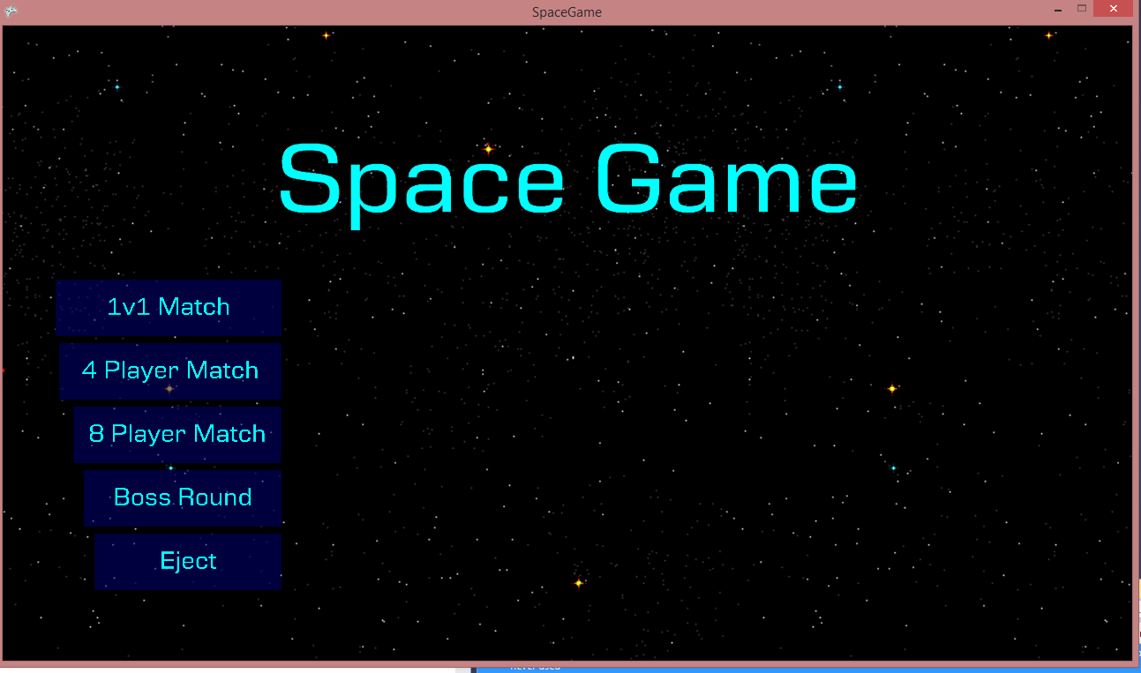

*Figure 1 – Start Screen*

As can be seen in the screenshot above when beginning the game you will be greeted with this screen, which gives you the option to take part in various different game modes that will be available to you. The first of which is a 1v1 match that will see you take part in combat against 1 AI opponent. The 4 player match will see you competing against 3 AI opponents and the 8 player match will see you compete against 7 different opponents, depending on your preference at the time. The final option ‘Eject’ will see you leave the game and the window will close. (But why would you wanna do that?!)

## Customisation

After you have chosen to begin your game you will be greeted with the ability to customise your ships pilot from a wide variety of different models available, and you will then also be able to assign a colour to each of those models, making them your own.

When you are greeted with the customisation screen if you left click on the model it will change to another one that is available to you, once you have decided on which character you want, pressing the change colour button will then allow you to customise the colour of your characters armour and ship, customising your ship and pilot further.

## Gameplay

When you begin the game you will be welcomed by the gameplay screen, which will show all of the planets that you can capture and use to complete your ultimate goal. Win the game.

*Figure 2 – Game Window*

When you begin the game you (and any AI players) all start on your own planet, with your objective being to capture as many planets as you can before the time runs out. To take control of one of your ships all you need to do is left click on it, once you have clicked on the ship you then need to click on another planet to move your ship towards it, capturing that planet will then allow your ship to begin collecting resources that will help you reach your aim of winning the game. When collecting resources on a planet the amount of resources assigned to that single planet will begin to lower until it reaches zero. When a planets resources hit zero it will produce less resources, making it important that you move on and let the planet regenerate its resources.

There are three different kinds of resources that you will encounter on your travels throughout the game world; Fuel, minerals and anti-matter. The first of these, fuel is very important to you as it is what allows you to move from planet to planet, but also keeps your ships from being destroyed. If you keep your fuel level high it will allow you to take over more planets and help ensure that you have the best chance possible to win the game. Furthermore for each fuel resource that you gather you will gain one point towards your total which will help to dictate if you win the game. Other ways to gather these points are by collecting the other resources that are available to you on other planets. The first of these resources, minerals, are very common and can be found on most of the planets that you encounter throughout the universe, and each normal mineral will add one point to your total. The final resource that you will encounter within the game world will be Anti-matter, this will is a very rare mineral that will provide you with a huge advantage to your score, it can only be found on certain planets [And once it is gone its gone?] and provides you with a huge 20 point bonus to your score for each anti-matter mineral that you find, helping you gain a large advantage towards winning the game.

As you float around the world adding planets to your collection you will eventually begin to run into planets that are owned by other colonies throughout the universe, if you land on one of these planets you will begin to colonise it and make it one of your own, eventually turning it into your side. You may however find that the other colonies send one of their ships to meet you there, initiating an interaction between the two of you within which you will have to make your own decisions, there are two buttons that will appear in your status screen, the first of these two options will be the ability to capture the enemies planet while you are circling it, allowing you to take the enemies planet whilst you are on it. The other option that will be available to you while you are on there will be to attack the other ship. Attacking the ship will see your HP(and the enemies HP) fall as you do damage to each other. Be wary though however because if your HP hits zero then your ship will be destroyed, and if all of your ships are destroyed it will be game over. The final option that is available would be to retreat from the planet back to one of your own to prevent them from you receiving any more damage to yourself.

There are two main ways available to you to win the game and control the galaxy, the first of these is to eliminate all of your opponent’s ships, if they have no ships left and no other ways to collect resources you then rule the galaxy. The other way to win is by having the highest amount of points at the end of the designated time limit. This would make you the strongest colony in the galaxy and everyone else would have to bow to your greatness, making you the winner.

Although you can win these ways you also have to be wary of the ways that you could lose the game, the first of these is by losing all of your own ships, either by your opponents destroying them or them being destroyed by your ship running out of fuel, the other way that you could find yourself losing this battle is by not gaining enough points from collecting your resources, this means that you need to ensure to keep collecting resources as much as you possibly can to give yourself the biggest advantage you possibly can.

# Space Game – Administrator Guide

This section of the user guide is for any potential administrators that may be using this game for their research purposes. The first section of the administrate use that this will cover will be the data logging what will be important for your research.

## Data Logging

Within the ‘DATAOUTPUT’ folder that is available in the root directory folder that will hold all of the data that will be recorded from both the users and the AI, the decisions that they made and the actions that they decided to partake in. It will also note what model was being used by the user and the AI at that time, which will help to tailor the results and provide a wider range of information, which can all be easily accessed.

## Rulseset Alteration

There will also be, alongside the ability to view the logged data, another file in the root directory called ruleset, this will allow you, the administrator to alter the settings that will be used within the game, such as how many ships available to each user, or how much each resource will be worth. This can also help when it comes to tailoring the results.